1. **Using Opencv play Video in Reverse mode**

**Aim:**

To play video in reverse using opencv.

**Code:**

import cv2

video_path = r"C:\Users\prith\Documents\CV\cvVideo.mp4"

cap = cv2.VideoCapture(video_path)

if not cap.isOpened():

print("Error: Could not open the video file. Check the file path.")

exit()

total_frames = int(cap.get(cv2.CAP_PROP_FRAME_COUNT))

current_frame = total_frames - 1

while current_frame >= 0:

cap.set(cv2.CAP_PROP_POS_FRAMES, current_frame)

ret, frame = cap.read()

if not ret:

print(f"Error: Unable to read frame {current_frame}.")

break

cv2.imshow('Video in Reverse', frame)

if cv2.waitKey(25) & 0xFF == ord('q'):

break

current_frame -= 1

cap.release()

cv2.destroyAllWindows()

**Output:**

**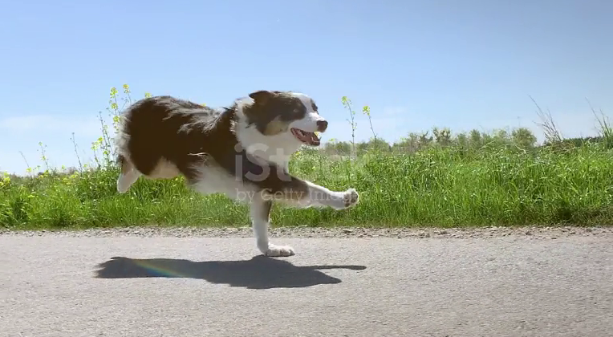  
  
Result:**

The python code to play video in reverse using opencv has been executed successfully.